LIVERMEAD CLIFF
HOTEL

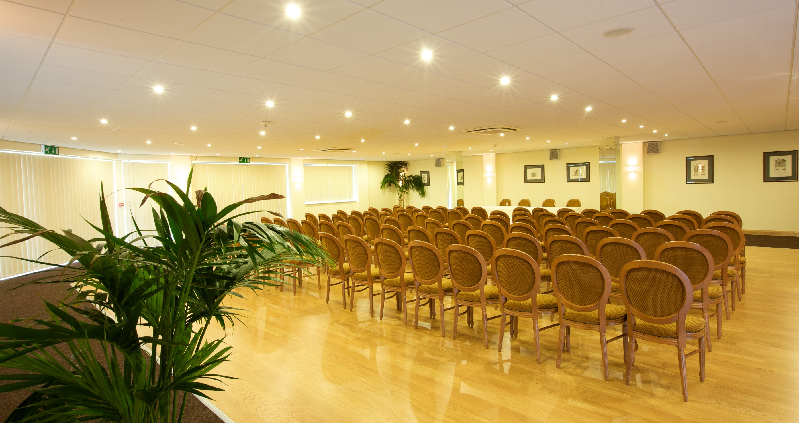

Conference 2019

“It makes Business Sense”

BEST WESTERN LIVERMEAD CLIFF
SEA FRONT – TORQUAY – DEVON – TQ2 6RQ
TELEPHONE 01803 299666
Email – enquiries@livermeadcliff.co.uk
Website – www.livermeadcliff.co.uk

Conferences

The newly refurbished Riviera Suite is a purpose built, airy and Well lit conference venue at the Best Western Livermead Cliff Hotel.

It was designed with expert advice to provide the facilities demanded by organisers of modern conferences and seminars. The conference rooms now also have wireless Internet access.

We can accommodate up to 200 delegates in the main conference room, depending on seating requirements. Additional syndicate rooms can be organised to hold various numbers of delegates upon request.

Day Delegate and 24 Hour Delegate rates are available as well as individual room rates, so whatever your need we hope to be able to meet your requirements.

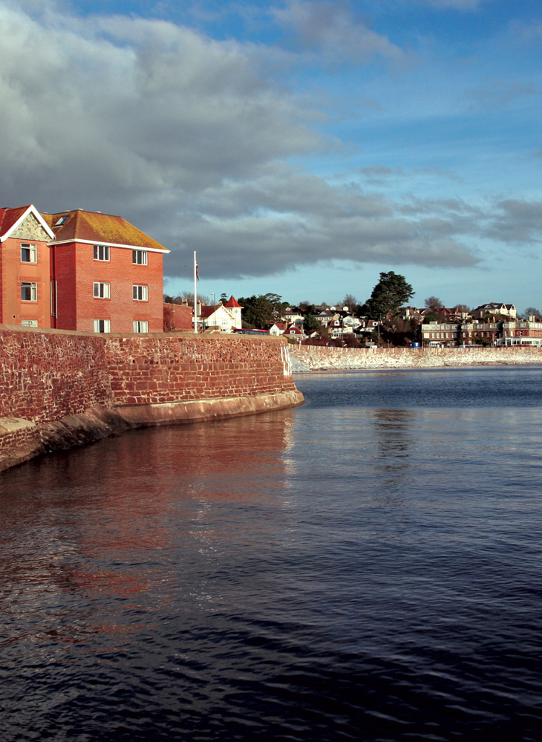
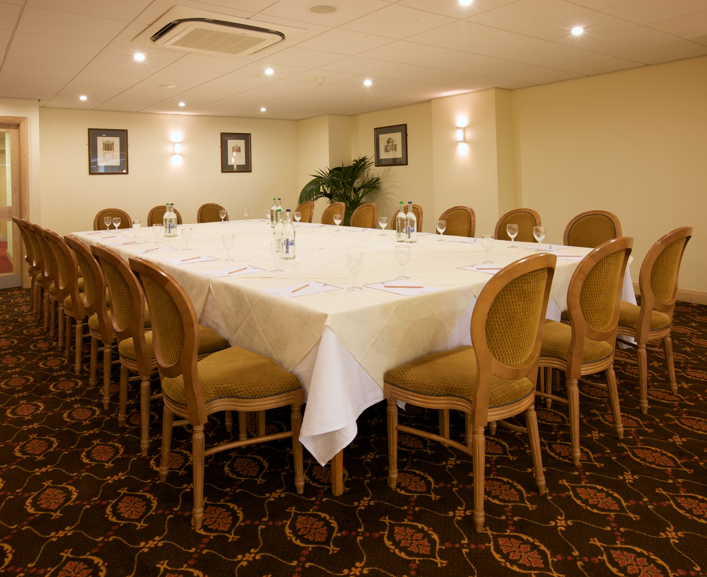

Conference Rates 2019

Day Delegate Rate (Includes Room Hire)

To include Coffee and Danish Pastries on arrival, Mid Morning Coffee with biscuits, Buffet Lunch, Afternoon tea with biscuits, V.A.T

£43.50 per Delegate (Minimum 10 Delegates)

24 Hour Delegate Rate (Includes Room Hire)

To include day delegate package plus overnight en-suite accommodation, 4 course Table d’hôte Dinner and Coffee, Full English Breakfast, V.A.T and Service

January to March from £110.00
April to June from £120.00
July to September from £130.00
October to December from £120.00

Single Occupancy in a Double Room carries a £30 supplement per night

Hotel Audio Visual Equipment:-

Overhead Projector, screen, Flipcharts, Whiteboard and P.A. System, Television and Video.

Data Projector available for hire £50

Super Bright Data projector available for hire, please ask for details

Individual Item Charges

Room Hire

Small Meeting (6-25 people) £135 per 4 hours (Sessions)
Large Meeting (25 – 200 people) £275 per 4 hours
Discounts available depending on numbers & catering supplied

Equipment

This is provided Free of Charge if items are in the property of the hotel. More specific requests for equipment are easily accommodated but we would request that a minimum of 48 hours notice is given to meet your requirements. Hired items such as data projectors & Screen are subject to additional charges.

Catering

Tea/Coffee per person £3.20

Tea/Coffee & Homemade Biscuits per person £3.50

Tea/Coffee & Danish Pastries per person £7.00

Buffet(s) per person – From £15.00

Luncheon per person:

- 3 Course & Coffee from £25.00

Dinner per person:

- 4 Course & Coffee from £33.00

For further details please contact:

- Charles Large
- Tom Newman
- Anthony Rew

Tel: (01803) 299666
Fax: (01803) 294496
Email: info@livermeadcliff.co.uk

